SIMATS ENGINEERING

Department of Computer Science & Engineering
ASSESSMENT TOOL 1- ANALYTICAL PROBLEM SOLVING

Course Code: | CSA1205 | Course Title: | Computer Architecture
CO Assessed: | CO2 | Assessment: | ASSESSMENT TOOL1-ANALYTICAL PROBLEM SOLVING
Weightage: | 45% | Total Marks: | 25
CO2 Statement: | Apply integer and floating-point arithmetic algorithms including Booth's multiplication, restoring/non-restoring division, and IEEE 754 standard operations to solve fixed-point and floating-point computational problems. (BL3)
Student Name: | MAHALAKSHMI S | Reg.No.: | 192524372
Department: | AI DS | Date: | 28-07-2026

ANNEXURE A

- A processor performs arithmetic operations on signed 8-bit integers using 2’s complement representation. Consider two numbers: +45 and −23. Analyse in detail how the system performs both addition and subtraction, including binary conversion, alignment of sign bits, and intermediate steps. Determine whether overflow occurs, and explain how the processor detects overflow and interprets the final result.
- Problem Understanding (20%)

A processor performs arithmetic on signed 8-bit integers using 2's complement representation.

Given:

  - Number A = +45

  - Number B = −23

Method Selection (20%)

The processor uses the 2's Complement Method because:

  - Positive and negative numbers are represented using the same adder.

  - Subtraction is performed as addition of the 2's complement.

  - No separate subtraction hardware is required.

  - Overflow can be detected easily.

Solution Process (25%)

Step 1: Convert +45 into Binary

45 =

32 + 8 + 4 + 1

Binary:

00101101

So,

+45 = 00101101

Step 2: Convert −23 into Binary

First convert +23.

23 =

16 + 4 + 2 + 1

Binary:

00010111

Take 1's complement 11101000
Add 1

11101001

Therefore

−23 = 11101001

Addition

(+45) + (−23)

00101101

+ 11101001

1 00010110

Discard carry out.

Result

00010110

Binary 00010110
Decimal 16 + 4 + 2
=22

Therefore Answer = +22

Overflow Check Rule:

Overflow occurs only if

- Positive + Positive = Negative or

- Negative + Negative = Positive

Here

Positive + Negative No overflow.
Overflow Flag = 0 Carry Flag = 1 (ignored)
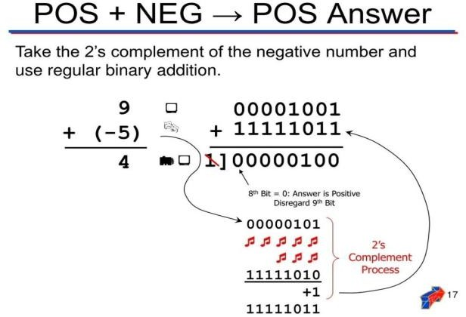

Subtraction

(+45) − (−23)

Subtracting a negative means adding its positive value. So,
45 − (−23)

=45 +23

Convert +23

00010111

Now add

00101101

+ 00010111

01000100

Binary 01000100
Decimal 64 + 4
=68

Therefore Answer = +68 No overflow.
Overflow Flag = 0

Processor Overflow Detection
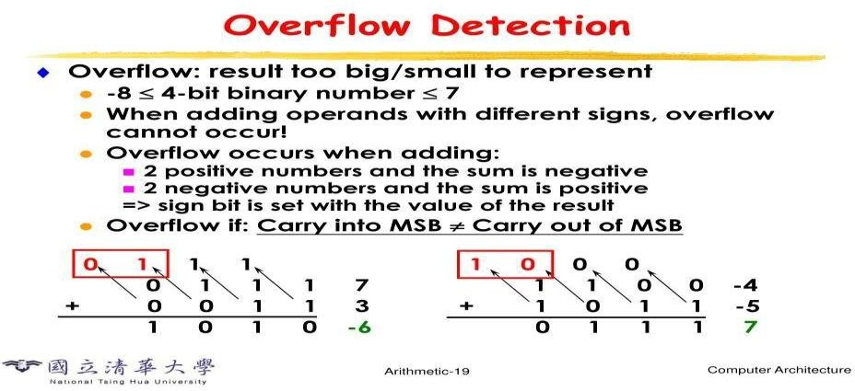
The processor compares

- Carry into MSB

- Carry out of MSB Overflow occurs if
Carry into MSB ≠ Carry out of MSB When
- Two positive numbers produce a negative result.

- Two negative numbers produce a positive result.

In this problem

Carry values are equal.

Hence

Overflow = No

Final Results

Operation Binary Result Decimal Result Overflow

+45 + (−23) 00010110 | +22 | No
+45 − (−23) 01000100 | +68 | No

Accuracy of Calculation (20%)

• +45 = 00101101

  - −23 = 11101001

  - Addition Result = 00010110 = +22

  - Subtraction Result = 01000100 = +68

  - Overflow Flag = 0

  - Carry out is ignored in 2's complement arithmetic.
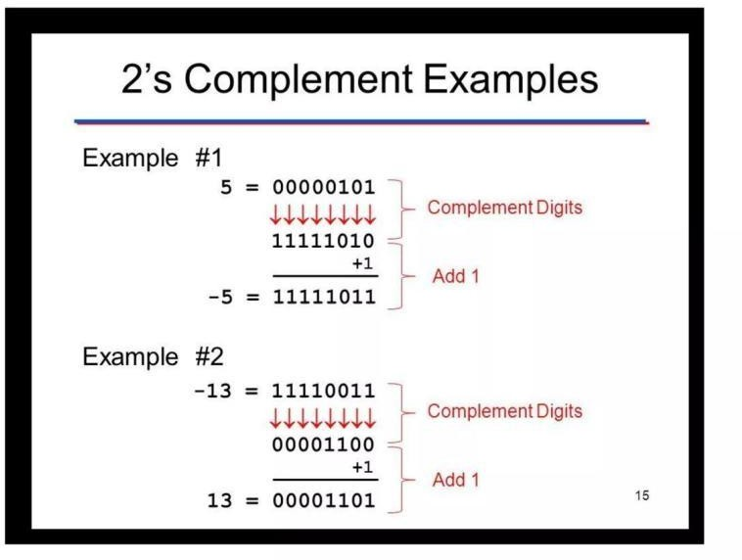

2.A high-performance computing system replaces a ripple carry adder with a 4-bit carry lookahead adder (CLA) to reduce computation delay. Given two binary inputs, analyze how generate and propagate signals are formed and how carries are computed in advance. Compare the time delay of CLA with ripple carry addition and justify, with reasoning, why CLA improves speed in modern processors.
- Problem Understanding (20%)

A processor replaces a 4-bit Ripple Carry Adder (RCA) with a 4-bit Carry Look-Ahead Adder (CLA) to reduce computation delay.

Given:

  - Two 4-bit binary numbers:

o A = 1011₂ (11₁₀)

o B = 0110₂ (6₁₀) •
Initial Carry (C₀) = 0

Method Selection (20%)

A Carry Look-Ahead Adder (CLA) is selected because it computes all carry bits simultaneously instead of waiting for the previous carry.

Formulae

Generate Signal

𝐺𝑖 =𝐴𝑖 ×𝐵𝑖

Propagate Signal

𝑃𝑖 =𝐴𝑖 ⊕𝐵𝑖

Carry Equations

𝐶1 =𝐺0 +𝑃0𝐶0
𝐶2 =𝐺1 +𝑃1𝐺0 +𝑃1𝑃0𝐶0
𝐶3 =𝐺2 +𝑃2𝐺1 +𝑃2𝑃1𝐺0 +𝑃2𝑃1𝑃0𝐶0
𝐶4 =𝐺3 +𝑃3𝐶3

Sum Equation

𝑺𝒊 =𝑷𝒊 ⊕𝑪𝒊

Solution Process (25%)

Step 1: Write Inputs

A = 1011

B = 01100

C0 = 0

Bit positions

Bit | A | B
3 | 1 | 0
2 | 0 | 1
1 | 1 | 1
0 | 1 | 0
Step 2: Calculate Generate (G) and Propagate (P)

Bit 0 A₀=1 B₀=0 G₀=1×0=0 P₀=10=1

Bit 1

A₁=1

B₁=1 G₁=1

P₁=0 Bit 2
A₂=0

B₂=1 G₂=0

P₂=1 Bit

3
A₃=1
B₃=0
G₃=0
P₃=1
Table Bit | G | P
0 | 0 | 1
1 | 1 | 0
2 | 0 | 1
3 | 0 | 1

Step 3: Calculate Carry Signals Carry C₁
C1 = G0 + P0C0

=0+(1×0)

=0

Carry C₂

C2 = G1 + P1G0 + P1P0C0

=1+0+0

=1

Carry C₃

C3 = G2 + P2G1 + P2P1G0 + P2P1P0C0

=0+(1×1)+0+0

=1

Carry C₄

C4 = G3 + P3C3

=0+(1×1)

=1

Step 4: Calculate Sum Bits S₀
S0=P0C0

=10

=1

S₁
S1=P1C1

=00

=0

S₂ S2=P2C2
=11

=0

S₃
S3=P3C3

=11

=0

Final Sum S3 S2 S1 S0 0001
Carry Out = 1 Hence,
Result = 10001₂ Decimal:
11 + 6 = 17

Final Answer = 17

Comparison: CLA vs Ripple Carry Adder

Feature | Ripple Carry Adder | Carry Look-Ahead Adder
Carry Generation | Sequential | Parallel
Speed | Slow | Very Fast
Delay | High | Low
Hardware | Simple | More Complex
Performance | Suitable for small circuits | Suitable for modern processors
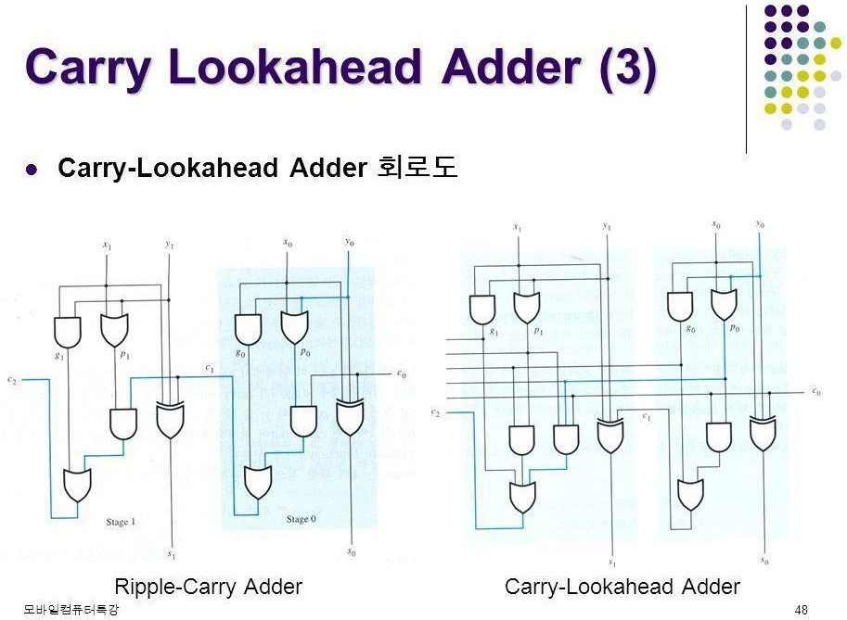

Carry Look-Ahead Adder

  - Carries are computed simultaneously using logic gates.

  - Delay is almost constant for small adders.

Delay ≈ log₂(n) Thus,

CLA is much faster than Ripple Carry Adder, especially for large word sizes (16-bit, 32-bit, 64-bit).
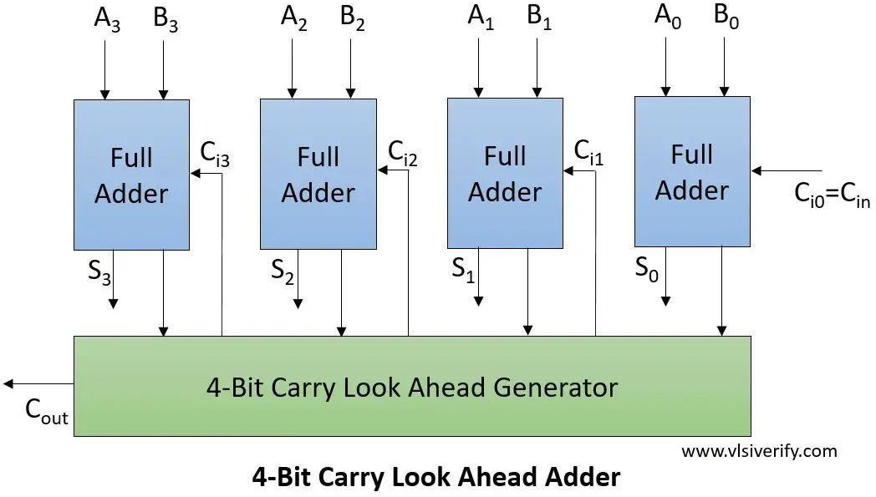

Accuracy of Calculation (20%)

  - Generate signals calculated correctly.

  - Propagate signals calculated correctly.

  - Carry values:

o C₁ = 0 o C₂ = 1 o C₃ = 1 o C₄ = 1
  - Sum = 10001₂

  - Decimal result = 17

- In a signed multiplication operation, a processor uses Booth’s algorithm to multiply two numbers,
−6 and +5. Analyse the algorithm step-by-step, including the role of the accumulator, multiplier, and Booth bit, along with arithmetic shifts. Explain how the algorithm efficiently handles signed numbers and reduces the number of addition/subtraction operations compared to traditional multiplication.
  - Problem Understanding (20%)

A processor performs signed multiplication using Booth's Algorithm.

Given:

- Multiplicand (M) = −6

- Multiplier (Q) = +5

Method Selection (20%)

Booth's Algorithm is selected because:

- It efficiently multiplies signed binary numbers.

- It uses 2's complement representation.

- It reduces the number of addition and subtraction operations.

- It handles both positive and negative numbers without separate sign processing.

Booth's Rules

Q₀ Q₋₁ Operation

- No Operation

- A = A + M

- A = A − M

Q₀ Q₋₁ Operation

- No Operation

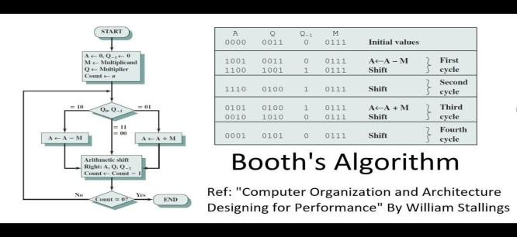
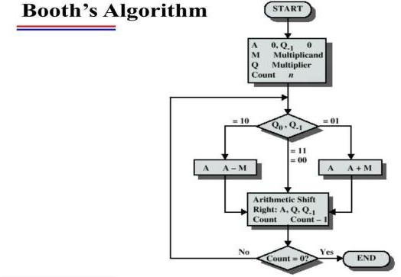
After every operation, perform an Arithmetic Right Shift (ARS).

Solution Process (25%)

Step 1: Binary Representation

Multiplicand (M = −6)

+6 = 0110

Take 2's complement: 1's complement = 1001 Add 1 = 1010 Therefore:
M = 1010 (-6)

-M = 0110 (+6)

Multiplier (Q = +5) Q = 0101
Initial Values A = 0000
Q = 0101 Q-1

= 0

Count = 4

Step 2: Booth Iterations

Iteration 1

Q₀Q₋₁ = 10 Rule:

A = A − M

A = 0000

−M = 0110

A = 0110

Arithmetic Right Shift Before Shift
A = 0110

Q = 0101

Q-1 = 0

After Shift A = 0011
Q = 0010

Q-1 = 1

Iteration 2

Q₀Q₋₁ = 01 Rule:

A = A + M

A = 0011

M = 1010

A = 1101

Arithmetic Right Shift A = 1110
Q = 1001

Q-1 = 0

Iteration 3

Q₀Q₋₁ = 10 Rule:

A = A − M

A = 1110

−M = 0110

A = 0100

Arithmetic Right Shift A = 0010
Q = 0100

Q-1 = 1

Iteration 4

Q₀Q₋₁ = 01 Rule:

A = A + M A = 0010
M = 1010

A = 1100

Arithmetic Right Shift A = 1110
Q = 0010

Q-1 = 0

Count becomes 0. Step 3: Final Product Combine A and Q
AQ = 11100010

Since MSB = 1, the result is negative. Find magnitude:
11100010

1's complement 00011101 Add
1

00011110 Binary:

00011110 = 30

Therefore, Product = -30 Verification
(-6) × (+5) = -30

Final Product = 11100010₂ = -30₁₀

Comparison with Traditional Multiplication

Feature | Traditional Multiplication | Booth's Algorithm
Signed Numbers | Extra handling required | Directly supported
Add/Subtract Operations | More | Fewer
Speed | Slower | Faster
Hardware Efficiency | Moderate | High
Used in Modern CPUs | Rare | Yes

Accuracy of Calculation (20%)

- Multiplicand (−6) = 1010₂

- Multiplier (+5) = 0101₂

- Four Booth iterations completed correctly.

- Final Product = 11100010₂

- Decimal Result = −30

4.A processor is required to perform division of two binary numbers (e.g., 13 ÷ 3) using both restoring and non-restoring division algorithms. Analyze both methods step-by-step, showing intermediate remainders and quotient formation. Compare the two approaches in terms of number of steps, complexity, and efficiency, and explain why non-restoring division is often preferred in modern systems.

Problem Understanding (20%)

A processor performs binary division using the Restoring Division Algorithm.

Given:

- Dividend = 13₁₀

- Divisor = 3₁₀

Requirements:

- Convert the numbers into binary.

- Perform restoring division step by step.

- Show the contents of Accumulator (A) and Quotient (Q) after each iteration.

- Explain the restoring operation.

- Determine the Quotient and Remainder.

Method Selection (20%)

The Restoring Division Algorithm is selected because:

- It is suitable for binary division in processors.

- It repeatedly subtracts the divisor from the accumulator.

- If the subtraction gives a negative result, the original value is restored by adding the divisor back.

- It is simple to implement in computer hardware.
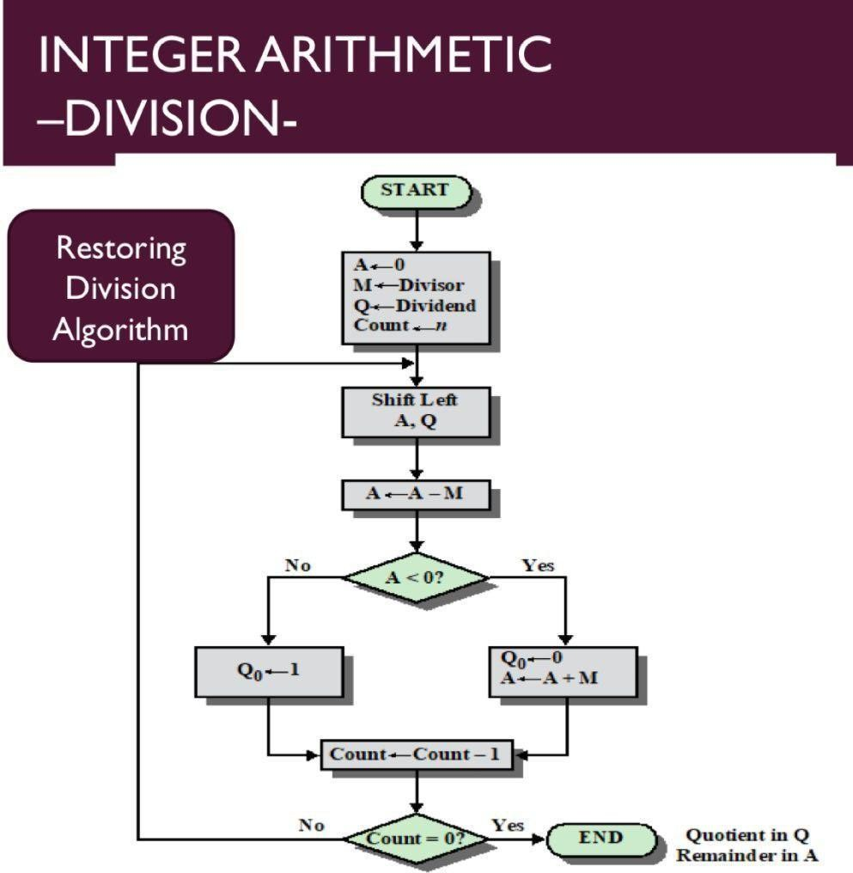

Solution Process (25%)

Step 1: Convert Decimal Numbers to Binary

Dividend = 13

13 = 1101₂

Divisor = 3

3 = 0011₂ Initialize:

A = 0000

Q = 1101

M = 0011

Count = 4

Step 2: Division Iterations Iteration 1
Left Shift (A,Q) A = 0001 Q
= 1010

Subtract Divisor A = 0001 − 0011
A = 1110 (Negative) Since A is negative:
- Restore A

A = 1110 + 0011

A = 0001

Set Q₀ = 0 Result
A = 0001

Q = 1010

Iteration 2 Left Shift A = 0011
Q = 0100

Subtract 0011 − 0011

=0000

Positive Set Q₀ = 1 Result
A = 0000

Q = 0101

Iteration 3

Left Shift A

= 0000

Q = 1010

Subtract 0000 − 0011
=1101

Negative Restore 1101 +0011
=0000

Set Q₀ = 0 Result
A = 0000

Q =1010

Iteration 4 Left Shift A =0001

Q =0100

Subtract 0001−0011 =1110
Negative Restore 1110+0011
=0001

Set Q₀=0 Final A=0001 Q=0100
Final Result Quotient 0100₂ = 4₁₀ Remainder 0001₂ = 1₁₀ Verification 13 ÷ 3
Quotient = 4

Remainder = 1

Since (3 × 4) +

1 = 13

The answer is correct.

Comparison: Restoring vs Non-Restoring Division

Feature | Restoring Division | Non-Restoring Division
Restoration | Required if result is negative | Not required
Speed | Slower | Faster

Hardware Complexity | Simple | Slightly Complex
Number of Operations | More | Fewer
Efficiency | Moderate | High

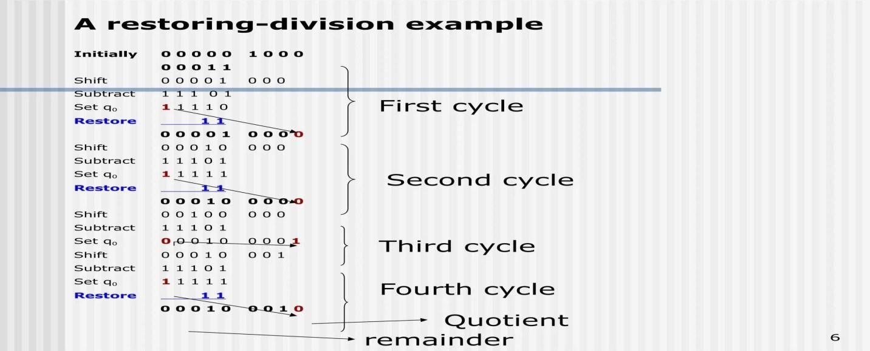

Accuracy of Calculation (20%)

- Dividend = 1101₂

- Divisor = 0011₂

- Quotient = 0100₂ (4₁₀)

- Remainder = 0001₂ (1₁₀)

- Verification: (3 × 4) + 1 = 13, confirming the result is correct.

5.A scientific application requires precise handling of real numbers using the IEEE 754 standard for floating-point representation. Given a decimal number (e.g., −13.25), analyze how it is represented in both single precision and double precision formats, including sign, exponent, and mantissa fields. Further, explain how floating-point addition is performed between two such numbers, highlighting issues like normalization, rounding, and precision loss.

Problem Understanding (20%)

A processor stores real numbers using the IEEE 754 Single-Precision Floating-Point Standard. Given Number: −13.625
Requirements:

- Convert the decimal number to binary.

- Normalize the binary number.

- Determine the Sign bit, Exponent, and Mantissa (Fraction).

- Write the final 32-bit IEEE 754 representation.

- Explain why floating-point representation is preferred over fixed-point representation.

Method Selection (20%)

The IEEE 754 Single-Precision Standard (32-bit) is used because it provides a standard method to represent real numbers accurately.
IEEE 754 Single Precision Format

Field Number of Bits

Sign 1 bit

Exponent 8 bits

Mantissa (Fraction) 23 bits The exponent uses a Bias = 127.

Solution Process (25%)

Step 1: Convert Decimal to Binary

Integer Part (13)

13 ÷ 2 = 6 remainder 1

6 ÷ 2 = 3 remainder 0

3 ÷ 2 = 1 remainder 1 1

÷ 2 = 0 remainder 1 So,
13₁₀ = 1101₂ Fractional Part (0.625)
Multiply repeatedly by 2: 0.625 × 2 = 1.25 → 1
0.25 × 2 = 0.5 → 0

0.5 × 2 = 1.0 → 1

Therefore, 0.625₁₀ = 0.101₂
Hence,

13.625₁₀ = 1101.101₂

Since the number is negative,

-13.625 = -1101.101₂

Step 2: Normalize the Binary Number

Move the binary point so that only one digit remains before it. 1101.101₂
= 1.101101 × 2³

Step 3: Sign Bit

The number is negative. Sign = 1

Step 4: Exponent

Actual exponent 3
Bias = 127

Exponent = 127 + 3 = 130 Convert 130 into binary 130₁₀ = 10000010₂

Step 5: Mantissa (Fraction)

Remove the leading 1 from the normalized form. Normalized number
1.101101

Mantissa

10110100000000000000000

(23 bits)

Step 6: Final IEEE 754 Representation
Field Value
Sign 1

Exponent 10000010

Mantissa 10110100000000000000000
Final 32-bit Binary

1 10000010 10110100000000000000000

Or, 11000001010110100000000000000000

Verification
Component Value

Sign 1

Exponent 130 (10000010₂)

Mantissa 10110100000000000000000

Decimal Number −13.625
The IEEE 754 representation is correct.
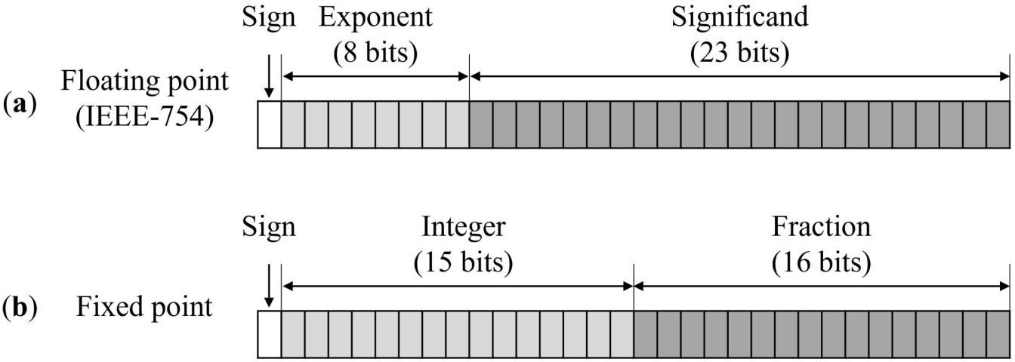

Accuracy of Calculation (20%)

- Decimal number −13.625 converted correctly to binary.

- Normalized form: 1.101101 × 2³.

- Sign bit = 1.

- Exponent = 10000010.

- Mantissa = 10110100000000000000000.

- Final 32-bit IEEE 754 representation: 11000001010110100000000000000000
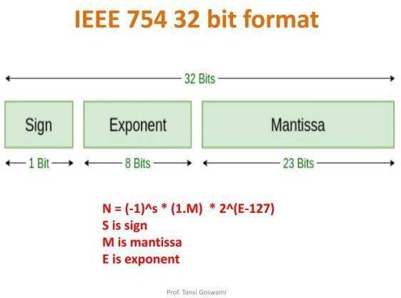
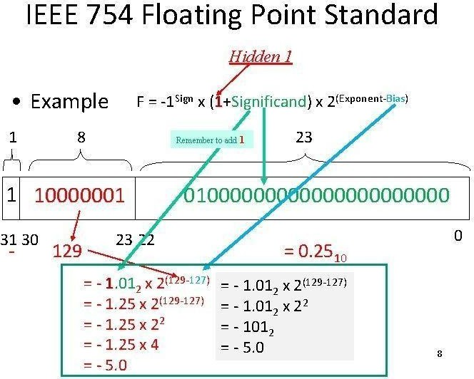

Code of Conduct:

I DG RAGHAVI 192521173 (Name / Reg No) certify that this submission is my original work and that I have adhered to the guidelines specified for this assessment.I understand that any violation of academic integrity rules will result in disciplinary action.
RAGHAVI DG
Signature of the student:

MARKS ALLOCATION
 | Problem Understanding (20%) | Method Selection  (20%) | Solution Process  (25%) | Accuracy of Calculation (20%) | Interpretation of  Results  (15%)
Q1
Q2
Q3
Q4
Q5

RUBRICS FOR CALCULATION:

Criteria | Weightage | Level 4 – Exemplary | Level 3 – Proficient | Level 2 – Developing | Level 1 – Beginning
Problem Understanding | 20% | Clearly interprets problem, identifies all parameters and requirements accurately | Understands problem with minor gaps | Partial understanding; misses key elements | Misinterprets or unable to understand problem
Method Selection | 20% | Selects most appropriate method/formula with strong justification | Selects correct method with minor errors | Inappropriate or partially correct method | Unable to select method
Solution Process | 25% | Logical, systematic steps with correct approach throughout | Mostly correct steps with minor mistakes | Disorganized steps; multiple errors | No clear process
Accuracy of Calculation | 20% | All calculations accurate; correct final answer | Minor calculation errors | Frequent errors; incorrect final answer | No valid calculations
Interpretation of Results | 15% | Clearly interprets results with units and engineering relevance | Basic interpretation with minor omissions | Limited or unclear interpretation | No interpretation

